**These are the notes referred to on the following official copy**

Title Number AGL175146

The electronic official copy of the document follows this message. This copy may not be the same size as the original.

Please note that this is the only official copy we will issue. We will not issue a paper official copy.

LAND REGISTRY

Land Registration Act 2002

We hereby certify this to be a true copy

of the original

*5 o Co*

*(CY -(._CJ -C9* ?.

COUNTY AND DISTRICT

TITLE NUMBERS

PROPERTY

DATE

The London Borough of Hillingdon

MX334541 (freehold) and MX349516 (leasehold)

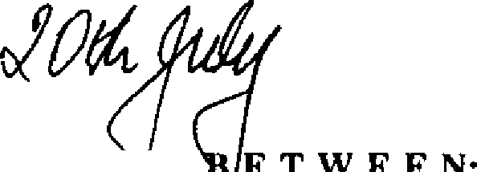First Floor Flat 3 Langham Court Station Approach South Ruislip Middlesex **HA46RX**

2007

**THIS DEED OF VARIATIONis** de --=--:..:....='-""-'...:..:.

ill "the Lessor" namely **S AIR GARDENS INVESTMENTS (KENSINGTON) LIMITED** (Company Registration Number 771453) whose registered office is at 16

The Precinct Bognar Regis West Sussex PO21 5SB and

ill "the Lessee" namely **BRENDA vvoJ>lNE WARING** of32 Wildwood Court Cedars Village Dog Kennel Lane Chorleywood Herts. WD3 5GG

# WHEREAS:-

**A.** This Deed is supplemental to a Lease ("the Lease") made the 30th day of October 1957 bt:{wet!n **DAVIS CONTRACTORS LIMITED** (1) **LILY KATHLEEN MAY NEATE** and

**FLATS AND ESTATES MANAGEMENT LIMITED** (3) (the Lease being varied by a Deed made the 21st July 1987 between the Lessor (I) and the Lessee (2)) whereby the property known as the first floor flat 3 Langham Court Station Approach South Ruislip Middlesex HA4 6RX ("the Demised Premises") was demised to the said Lily Kathleen May Neate for a term of 99 years from the 25th March 1957 at the yearly rent thereby reserved ("the Initial Rent") and subject to the covenants and conditions set out therein

The residue of the term granted by the Lease is now vested in the Lessee

The reversion expectant upon the expiry of the Lease is now vested in the Lessor The Lessee has requested the Lessor to vary the Lease in the manner hereinafter

appearing and the Lessor has agreed so to do (as it is in any event required to do pursuant to the provisions of the Leasehold Reform and Urban Development Act 1993 as amended ("the Act"))

**N O W T H** I **S D E** E **D W** I **T N E S S E T H** as follows:-

L. IN consideration of the sum of **TWENTY EIGHT THOUSAND FOUR HUNDRED**

**POUNDS** (£28,400) paid by the Lessee to the Lessor (the receipt of which the Lessor hereby acknowledges) the Lease shall be varied in the following manner:-

* 1. The term of the Lease shall be extended so as to be a term of one hundred and twenty-five years from the date hereof
  2. The Initial Rent reserved in Clause 1 of the Lease shall be varied so that the wording as to the rem reserved shall be:-

**"YIELDING AND PAYING THEREFOR** to the Lessor until the First Review Date

(being the 25th March 2028) an annual rent of **TWO lflJNDRED AND THIRTY**

**POUNDS** (£230) to be paid in advance without any deduction on the 29th September in every year the first of such payments being made on the execution hereof and from and after the First Review Date and from and after each following Review Date (herein meaning each twenty-first anniversary of the First Review Date) and until the following Review Date an annual rent of one seven-hundredth part (11700th) of the open market value of the Demised Premises as at the relevant Review Date such open market value being agreed between the parties prior to the Review Date and if not agreed by the Review Date as shall be determined by a Chartered Surveyor or recognised Valuer practising in the area of the Demised Premises such Surveyor or Valuer to be nominated by the Lessee within one month of a request so to do by the Lessor and appointed by the Lessor at the cost of the Lessee and failing such nomination then as appointed by the Lessor. For the purpose of this provision the open market value shall be assessed on the basis that all covenants and obligations on the Lessee's part contained in this Lease have been complied with and on the basis of a hypothetical sale of the Demised Premises between a willing seller and a willing buyer with full vacant possession on completion. References to periods of rime in this clause shall not be of the essence and the reference to the Review Date shall mean either the First Review Date or any following Review Date"

* 1. The covenants on the Lessee's part contained in Clause 2 of the Lease shall be varied

extended and modified as follows;-

* + - ill So that sub-clause (1) shall·read:

"To pay to the Lessor during the term the rents hereby reserved at the times and in the manner aforesaid without any legal or equitable set off or other deduction whatsoever"

ilil So that sub-clause (13) shall read:

"Not to assign transfer or underlet the Demised Premises without btaining from the Transferee Assignee or Underlessee a Deed of Covenant prepared by the Lessor at the Lessee's cost to observe and perform the covenants and obligations on the Lessee's part contained or referred to in this Lease and within one month of the completion of any such assignment transfer or underletting or assignment of such underlease or on the completion of any mortgage or charge of this Lease or any Probate Letters of Administration Order of Court or other instrument affecting or evidence of devolution of title as regards to the term hereby granted or any such underlease as aforesaid

li!l to give notice thereof to the Lessor with a certified copy of such

document for the Lessor's retention

fitl deliver the executed Deed of Covenant to the Lessor and

!fl pay the Lessor's reasonable fee for the registration of each Notice produced"

1. By the addition of the following sub-clauses:-

**"(22)** In the event that the Lessee shall fail to pay any sums due under this Lease within a period of twenty-eight days from the date of becoming due then interest shall be payable by the Lessee to the Lessor on

those sums in arrears in addition thereto at the rate of 5% per centum per annum above the base rate of National Westminster Bank pie (or any other Bank that the Lessor may determine) such sum being payable from the date the payment became due until actual payment in full

* 1. To pay to the Lessor by way of indemnity all proper and reasonable costs charges legal expenses and disbursements of whatever kind and reasonable remuneration incurred by the Lessor in the enforcement of the covenants contained in this Lease
  2. Wherever in this Lease or any Licence or Consent granted hereunder provision is made for the Lessee to pay any sum (including without prejudice to the generality of the foregoing rents legal costs registration fees Surveyors and other professional fees charges and expenses) on which Value Added Tax is payable or shall become payable the Lessee shall pay in addition to such sum Value Added Tax thereon at the rate appropriate at the time of supply"
  3. By the addition of the following sub-clause in Clause 5:

"ill The Lessor shall not be personalJy liable under any of the covenants on its part her i11 contained otherwise than in .respect of. breaches for which it is responsible"

**SAVE** as hereby modified the Lease shall continue in full force and effect in all respects as if the changes made by this deed had been originally contained in the Lease

**THE** Lessor and the Lessee hereby consent to the noting of this Deed against their respective titles by way of an agreed notice and jointly apply to the Chief Land Registrar to make the necessary entries on the Register of Title Numbers MX334541 and MX349516 in order to give effect to the terms of this Deed

**IN WITNESS** whereof the parties hereto have executed this document as a Deed the day and year first before written

**EXECUTED** as a Deed by **SINCLAIR GARDENS INVESTMENTS**

**(KENSINGTON) LIMITED** acting by a Director and the Secretary or by two Directors

)

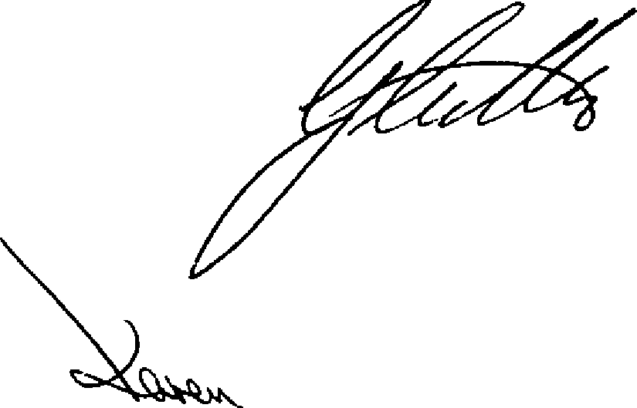)

)

)

) Director

- **,¼lcL**

' ecretary

·, .

2007

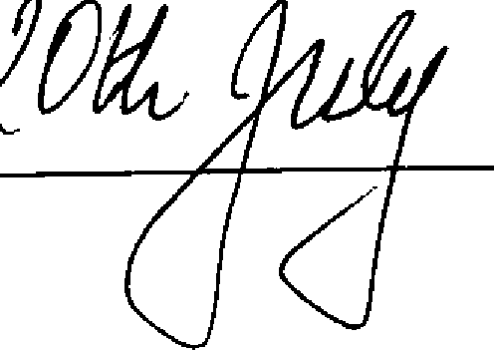

DATED

SINCLAIR GARDENS INVESTMENTS (KENSINGTON) LTD.

to

MRS B Y WARING

# D E E D O F V A.R I A T I O N

relating to

## First Floor Flat, 3 Langham Court, Station Approach,

**South Ruislip,**

## Middlesex,

**HA4 6RX**

Staffurth & Bray, York Road Chambers, Bognor Regis.

West Sussex,

P021 lLT

Ref: RT